**7.7 Angle of Depression and Angle of Elevation HW**

*You must draw a picture & show your work to receive full credit*

1. 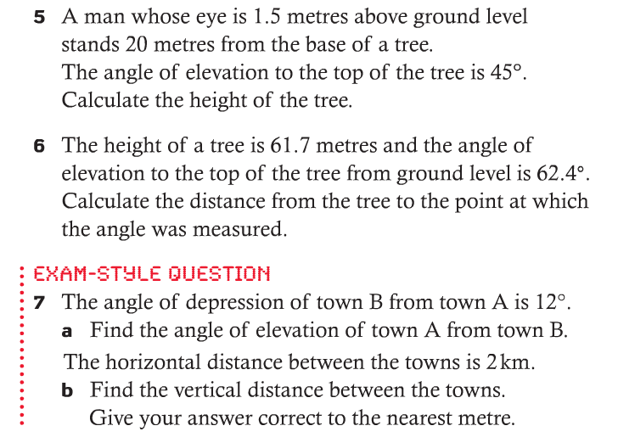

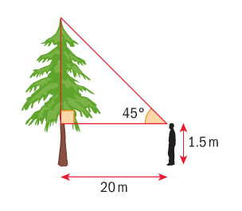

1. 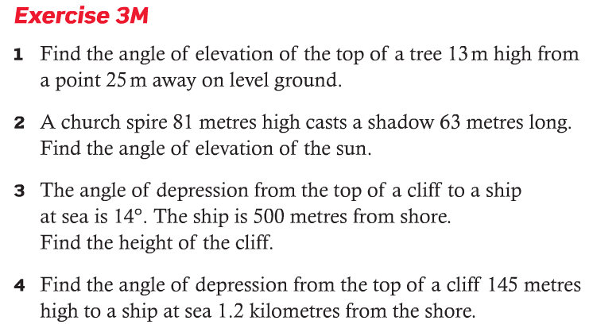
2. 

**REGENTS CHALLENGE QUESTIONS – 1 POINT OF EXTRA CREDIT EACH**



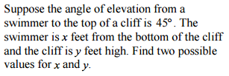

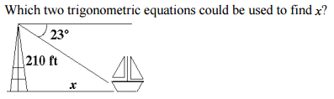

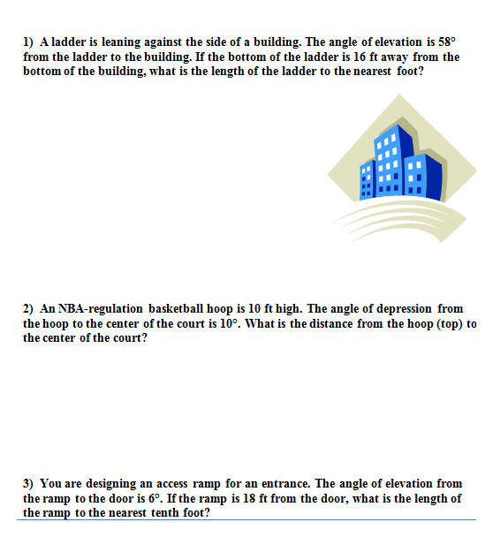



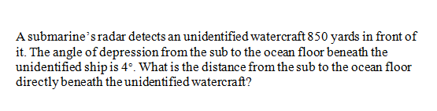

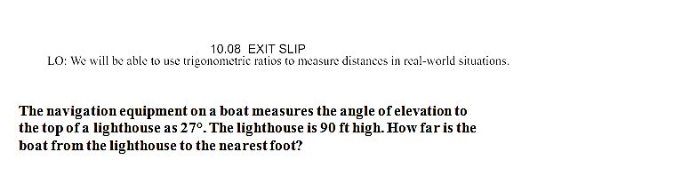

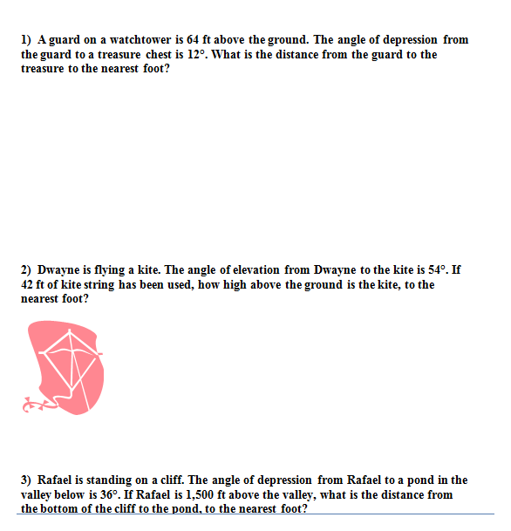





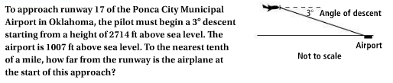

Screen%20Shot%202017-02-02%20at%2011.06.09%20PM.png

Screen%20Shot%202017-02-02%20at%2011.06.27%20PM.png

